**1050 Programming Logic**

Lab 3 (20 points total)

Name: Dhruvil Patel

*Paste your code and screenshots below.*

1. Compare and contrast the if single-selection statement and the while repetition statement. How are these two statements similar? How are they different? (2 Points).

Answer – The **if** single-selection statement is a true/false statement. The **while** repetition statement tells that a program should repeat an action under certain condition. The similarity of a single-section and while repetition statements are entry condition checking statements.  
The difference is **if** block outputs the code only once, where as **while** outputs statements repeatedly until the condition is met.

1. Declare two int variables: 1) speedLimit and 2) speed. Assign values speedLimit=35 and speed=42. Write an if statement that displays “SLOW NOW” if speed is greater than speedLimit. (2 points)

Code:

int speed;  
            int speedlimit;  
  
            speedlimit = 35;  
            speed = 42;  
  
            if (speed > speedlimit) ;  
            Console.WriteLine("SLOW DOWN");

Execution:



1. if-else statement - Write a program that declares and assigns a value to a Boolean variable called isTrue. Use a condition to output “It is True!” or “It is False!” based on the assigned value. Paste your code and screenshots of your program running with both true and false values (3 points).

Code(true):

int number;  
  
            number = 65;  
  
            Console.WriteLine(number>=60 ? "It is True!" : "It is False!");

Execution(true):



Code(false):

 int number;  
  
            number = 55;  
  
            Console.WriteLine(number>=60 ? "It is True!" : "It is False!");

Execution(false):



1. if statement - Write a program that converts a Fahrenheit temperature to Celsius. The user should be able to input the temperature at the Command prompt and it should output the temperature. In addition, you should output “It is cold” if the Fahrenheit value is less that 40 or it should output “It is hot” if the temperature is over 90 (4 points). ***Code to read a value: double fahrenheit = Convert.ToDouble(Console.ReadLine()); Code to convert: celsius = (fahrenheit - 32d) * 5d / 9d;***

Code:

Console.WriteLine("Enter temperature in fahrenheit:");  
  
            double fahrenheit = Convert.ToDouble(Console.ReadLine());  
  
            double celsius = (fahrenheit - 32d) * 5d / 9d;  
  
            Console.WriteLine("Temperature in celsius is {0}", celsius);  
  
            if (fahrenheit < 40)  
            Console.WriteLine("It is cold");  
            else if (fahrenheit > 90)  
            Console.WriteLine("It is hot");

Execution(hot):

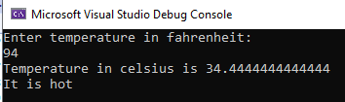

Execution(cold):

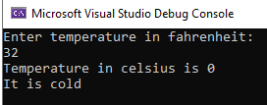

1. **Write a while loop** that outputs values 1-10. Increment by 1 (3 points).

Code:

int i = 1;  
            while(i<11)  
            {  
                Console.WriteLine(i);  
                i++;  
            }

Execution:

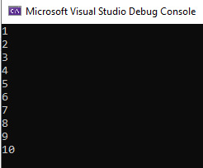

1. **Write a while loop** that outputs values 60 to 20. Decrement by 1 (3 points)

Code:

int i = 60;  
            while(i>19)  
            {  
                Console.WriteLine(i);  
                i--;  
            }

Execution:

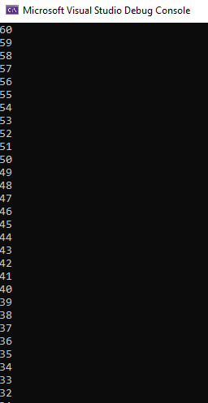

1. **Create a while** that outputs values 10-20 (3 points).

Code:

int i = 10;  
            while(i<21)  
            {  
                Console.WriteLine(i);  
                i++;  
            }

Execution:

